Claudio Castillo

CTS 2451

Prof. Norge Pena

01/13/2019

**Discussion 2- Tutorial 2**

To add a new item (report) to our current solution we can follow the following steps:

1. Right click on the folder “Reports” from the Solution explorer to add a new item.
2. The wizard will pop up and after clicking “Next” we will be prompted to select the Data Source. We already created it from the previous tutorial and naming it “Tutorial 1”.
3. 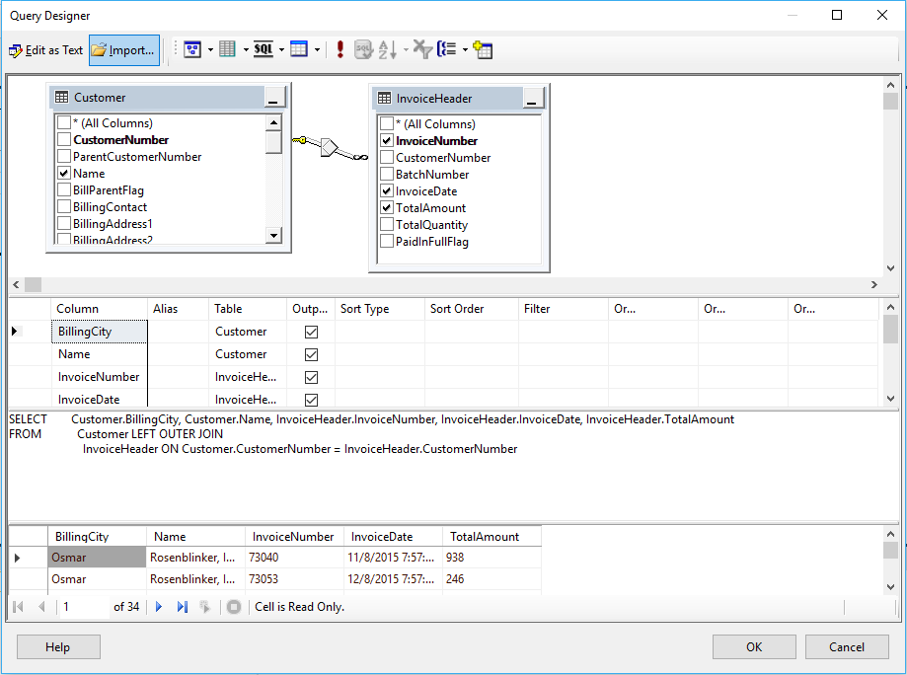Then we need to query our data using the query builder.
4. In the query builder we add the tables Customer and InvoiceHeader. Notice that those tables are connected on CustomerNumber field as shown in the line between both tables. That field is the Primary key in the table Customer and a Foreign key in the other one.
5. From the customer table we select the Name, and the BillingCity; from the InvoiceHeader table we select the invoicenumber, the Invoicedate and the TotalAmount.
6. To see if we are retrieving the right data from the data source then we can execute the SQL.
7. Select the Tabular Type of Report.
8. Now we need to display a report for every city that is why we drag Billingcity to the “Page” side. Since each Name (or customer) will have different invoices that is why we drag the field “Name” to be on the “Group” side. Everything else will be on the Details panel.

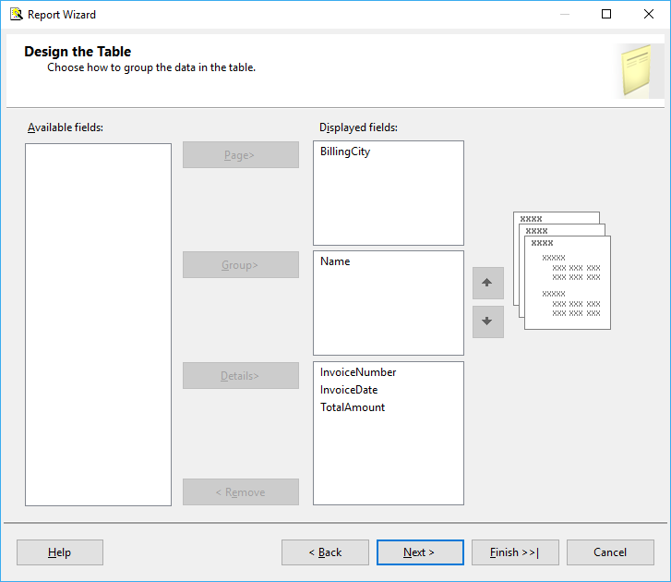

1. On the layout window we are going to select the “Stepped” Option and we are going to enable the drilldown and the subtotals options.
2. After that we proceed to name our report

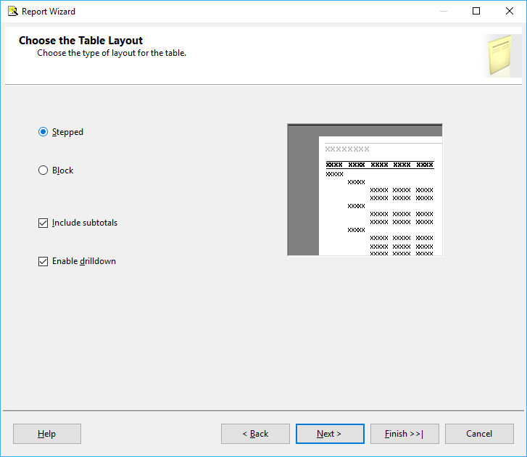

1. The following picture represent one page of the final report. Notice that we changed the format of the Total amount to make it look nicer (Shown as Currency)

